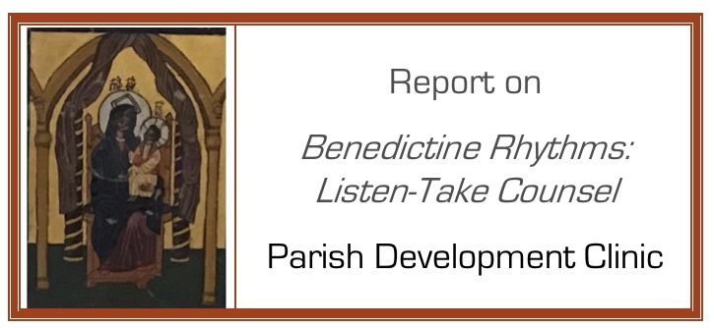

By September 10, 2018 -- Please use this form to report on your use of “Taking Counsel – Stop Grumbling”

1. What are your objective? What do you want to accomplish?

2. What’s your action plan? – an outline will do

Action to take By when

3. Results – what was the impact in your parish?

4. What where two important learnings you had regarding “Take Counsel – Stop Grumbling?”

Complete this section after you have finished the project, and no later than December 10, and return to Robert Gallagher, OA by email.

5. What where two important learnings you had regarding the process of change?

Complete this section after you have finished the project, and no later than December 10, and return to Robert Gallagher, OA by email.

